

Patellar Tracking in Primary Total Knee Arthroplasty
Edward J. McPherson, M.D., F.A.C.S.

Director, Department of Orthopedic Surgery
L.A. Orthopedic Institute
Patellar Tracking in Primary Total Knee Arthroplasty

Edward J. McPherson, MD

Primary total knee arthroplasty (TKA) is a technically challenging procedure that if performed with reasonable skill, can provide significant pain relief and patient satisfaction. The success of this procedure is influenced by many factors, the most notable of which include implant design, component alignment, and ligament balancing. The patellofemoral articulation is one portion of the procedure which too often is relegated to secondary importance. Not infrequently, the scenario toward the end of the procedure is the surgeon is ready to implant component parts, and quickly cuts the patella, drills the holes, and is ready to move on. Complications involving the patellofemoral articulation are not devastating. However, they should warrant particular attention. The most frequent complications in primary total knee arthroplasty involve abnormal patellar tracking ^{1,2,3,4,5,6}. To this end, this section is devoted to the discussion of concepts and tips on how to avoid patellar maltracking and to enhance optimal extensor function.

This section will address the following topics as it relates to patellofemoral tracking and function:

- Q angle importance in TKA
- Mechanical alignment
- Femoral component rotation
- Tibial component rotation
- Femoral component coronal positioning
- Tibial component coronal positioning
- Patellar component positioning
- Patellar height
- Patellar resurfacing

Q Angle Importance in TKA

The Q angle describes the extent of coronal angulation of the extensor mechanism at the knee. It is defined as the angle between the quadriceps tendon line and the patellar tendon line ⁷. The intersection is at the patella. The Q angle is closely related to the clinical valgus of the knee,but not always. In primary TKA, alterations in femoral, tibial, and patella component positioning can affect Q angle values without necessarily altering mechanical alignment. Because of the Q angle, there is always a resultant lateral subluxation force upon the patella (fig.1) ^{8,9}.

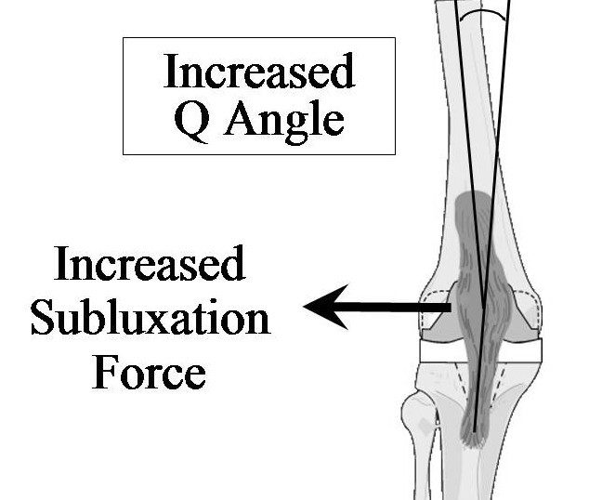

Figure 1: Increased Q Angle.
An increased Q angle increases
the lateral subluxation force of
the patella. The less constrained
femoral flanges of most total knee
systems are less able to tolerate
increased Q angle forces.

The importance of the Q angle in primary TKA relates to the trochlear groove. The majority of prosthetic trochlear flanges are less constraining than the native knee. Consequently, an increased Q angle pulls the patella more laterally. The clinical effects can be obvious, such as lateral patellar tilt, lateral patellar overhang, subluxation, and dislocation. However, the clinical effect can be more subtle ^{10,11,12}. Excessive lateral tilt places increased shear upon the prosthetic bone interface, and can result in early prosthetic loosening. Increased patellofemoral forces caused by maltracking can cause chronic anterior knee pain. Chronic irritability at the patellofemoral joint can also cause scar tissue to form, manifesting as patellofemoral clunk syndrome or a more diffuse “crunching” ^{13,14,15,16}. This is especially pronounced with sit to stand, and sometimes this can be heard across a quiet room. Therefore, to minimize patellofemoral maltracking, the surgeon should employ surgical techniques that optimize prosthetic function and stability, but does not increase Q angle alignment.

Mechanical Alignment

Mechanical alignment of the leg as it relates to the technique of primary TKA is defined as center of hip, through center of knee, to center of ankle¹⁷. Mechanical alignment should be restored to a neutral mechanical alignment. This optimizes prosthetic function and wear, but as it relates to the patellofemoral joint, a neutral mechanical alignment brings the Q angle into a normal range. If there are no femoral or tibial deformities, the Q angle is directly related to mechanical alignment of the leg. A net valgus mechanical alignment must be avoided as this increases the Q angle.

Mechanical alignment is controlled by two cuts: the distal femur and proximal tibia. The proximal tibia is typically cut at 90º to the mechanical axis. Therefore, the mechanical alignment of the leg is primarily controlled by the distal femoral cut. The distal femoral cut should never typically exceed 7º, as this would increase Q angle alignment.
The distal femoral cut can be measured preoperatively by determining the angle between the anatomic axis of the femur (AAF) and the mechanical axis of the femur (MAF) which extends to the hip center (fig. 2).

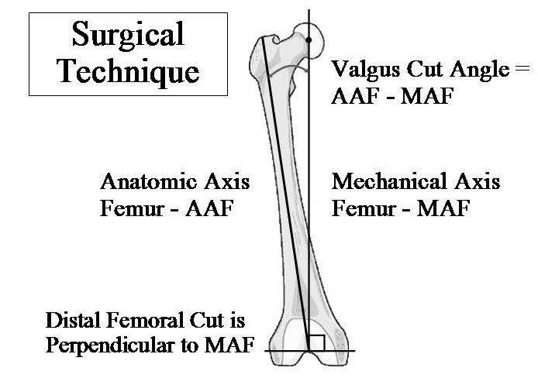

Figure 2: Valgus Cut Angle.
Surgical plan for distal femoral cut.
The distal femoral cut is made
perpendicular to the mechanical
axis of the femur. The intraoperative
reference is the anatomic axis of the femur. A medullary rod is placed into the femoral canal to represent the anatomic axis. The distal cutting jig is adjusted to make a perpendicular cut to the mechanical axis.

This requires a full length radiograph¹⁸. Typically the distal femoral cut angle is 4-7º. A distal femoral cut angle of 6º is a good choice if one does not routinely measure, as this value will accommodate for variation in the saw cut. Knee deformities with severe valgus or severe varus still should be corrected to a neutral mechanical alignment. Total knee systems are now comprehensive, and can accommodate difficult deformities with medullary stem support, metaphyseal metallic augmentation, and constrained tibial post designs.

The difficult scenarios occur with femoral and tibial boney deformities. These are typically a result of fracture with boney malalignment. Prior corrective osteotomies and congenital deformities can cause similar problems. As it relates to the patellofemoral joint, varus deformities of the femur close to the joint are the biggest problem. In these deformities, a distal femoral cut to achieve a neutral mechanical alignment will leave the Q angle increased. An example is a distal supracondylar femur fracture with a varus deformity of 5º. To restore the mechanical axis to neutral, the femoral valgus cut angle will need to be 11º (standard valgus cut angle of 6º plus 5º to correct for varus deformity). Most of the time, the increased Q angle can be treated with lateral retinacular release and medial capsular advancement. If however, significant maltracking persists, more difficult choices are required. The two options are 1) recut the distal femur to less valgus and accept a net varus mechanical alignment or 2) perform a concomitant corrective femoral osteotomy. These cases are too complex and variable to identify one superior treatment. A concomitant corrective osteotomy is technically demanding with any of the techniques used, and operative time is significantly increased. On the other hand, accepting a net varus alignment will excessively load the medial compartment and may lead to early prosthetic failure, and/or knee instability. A compromise solution would be to recut the femur and accept a small net varus mechanical alignment. This would be combined with a lateral retinacular release and medial capsular advancement to correct patellar tracking.
Femoral Component Rotation

The paramount rule with femoral component rotation is; do not internally rotate the femoral component. A femoral component that is internally rotated causes two main problems. First, an internally rotated femoral component relative to the extensor mechanism makes the patella appear laterally tilted (fig. 3) ^{19,20}.

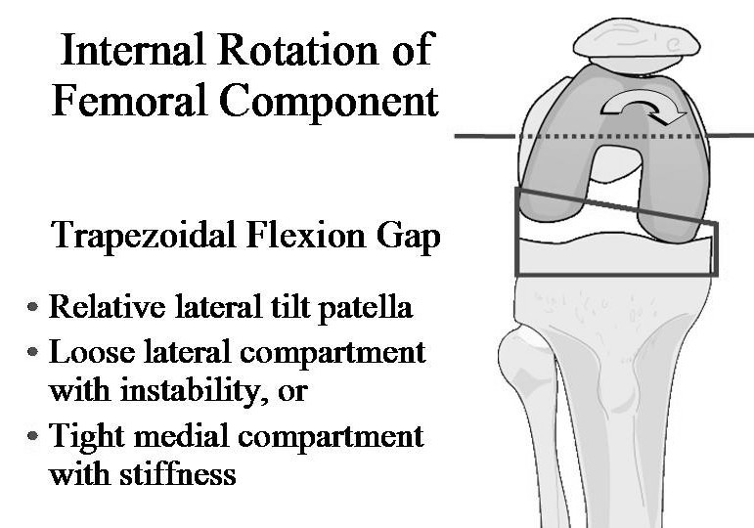

Figure 3: Internal Rotation of
Femoral Component.
Internal rotation of femoral
component. Internal rotation
of femoral component adversely
effects patellofemoral tracking
by medial displacement of the
patella and by creating a relative
lateral patellar tilt.
This places excessive shear stresses on the patellar component. Also, when the femoral component is internally rotated, the lateral flange will displace the patella more medially. It has been shown that 5º of femoral component internal rotation will displace the patella medially by 5mm²¹. The net result is an increased Q angle. The optimal rotation of the femoral component is slight external rotation. Most prosthetic knee systems use the posterior condylar axis as a reference, and use a jig that fits under each posterior femoral condyle. An external rotation value of 3º is typically the value chosen for external rotation. With more sophisticated third generation instrument systems, this value can be adjusted with a variable rotation device (fig. 4).

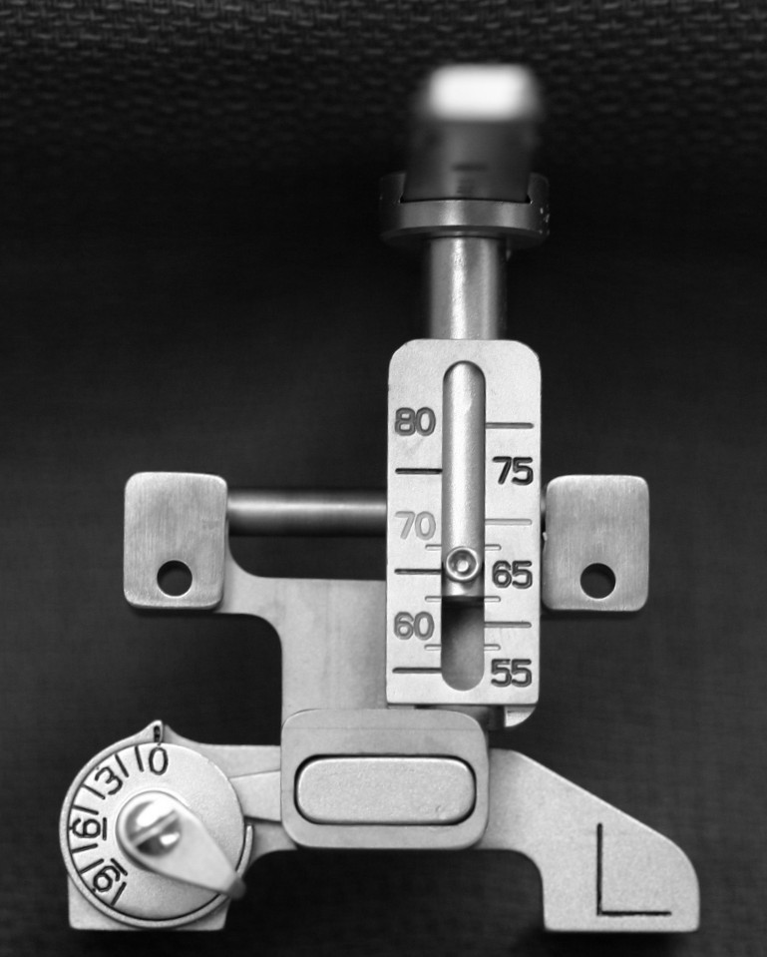

Figure 4: AP Sizer-bw-1-(2).
Photograph of AP sizing jig employing
variable rotation dial for femoral
component rotation. This jig uses posterior
metallic pads to define posterior condylar axis.
Rotation dial can adjust femoral component
rotation to any one of the four rotational
reference lines.
Courtesy of Biomet Inc., Warsaw, IN.
The value of 3º is an average value, but based on each clinical situation, an external rotation value between 2-5º is acceptable ²². The reason for slight external rotation of the femoral component relates to flexion gap balancing. With the knee at 90º of flexion, the joint line of the native tibia is not perpendicular to the tibial mechanical axis. On average, the native tibia rests in slight varus (fig. 5) ²³.

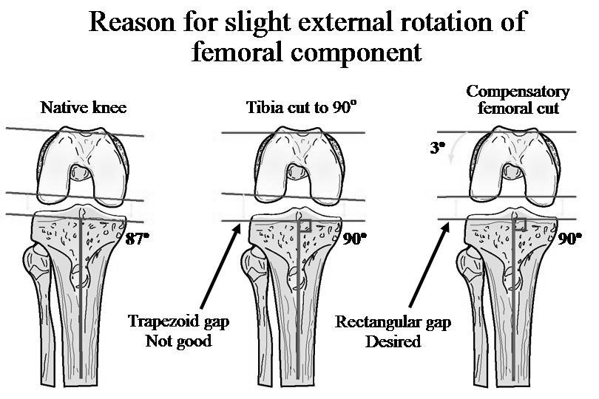

Figure 5: External Rotation Femur. Diagram showing reasoning for slight femoral component external rotation.
To create a neutral mechanical axis with the knee in extension, the tibial cut is made perpendicular to the
mechanical axis. In flexion however, the flexion gap is asymmetrical. Therefore, the femoral component must be externally rotated to equalize
the flexion gap.

When the tibia is cut perpendicular to the mechanical axis, the flexion gap created is trapezoidal, and is therefore unbalanced. To reestablish a balanced flexion gap, the femoral component is therefore externally rotated a comparable amount. As a corollary, knees with varus deformities tend to require more femoral component external rotation (3-5 degrees), and valgus deformities tend to require less femoral component external rotation (0-3 degrees). There are four technical methods to set femoral component external rotation²⁴. They are illustrated in figure 6.

Diagrams of the four reference lines used to set femoral component external rotation.

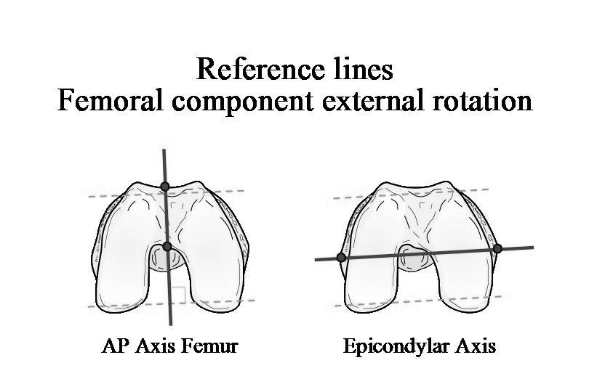

Figure 6a: Reference Lines Femur. AP axis described by Whiteside. Femoral component external rotation
is set to a line perpendicular to the AP axis. With the epicondylar axis, femoral
component external rotation is set parallel to this reference line.
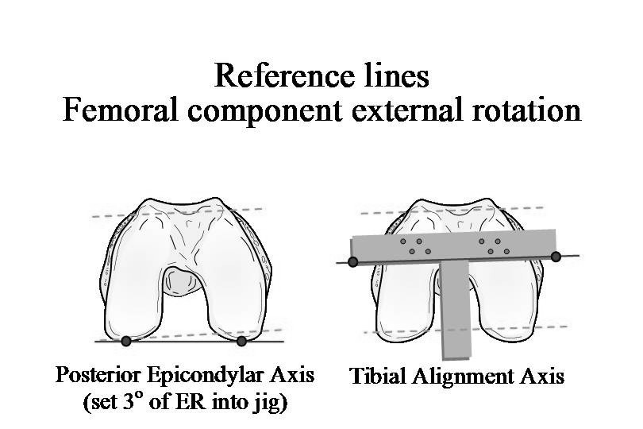

Figure 6b: Refernce Lines Femur. Posterior condylar axis. Femoral component external rotation is usually
set 3º to this axis. With the tibial alignment axis, femoral component external rotation
is set parallel to this reference line.

The anterior-posterior condylar axis described by Whiteside and Arima uses a line drawn from the top of the intercondylar notch up along the femoral trochlear groove. A line drawn perpendicular to this is the reference line for femoral component external rotation. This reference line prioritizes aligning the femoral component for optimal patellar tracking²⁵. The posterior condylar axis uses a line between the posterior femoral condyles at 90º of flexion. External rotation of a specific value is then chosen from this line, typically 3 degrees. Another reference line is the epicondylar axis. This line is drawn between the two epicondyles with the knee at 90º of flexion. The epicondylar axis is related to the posterior condylar axis, but as a general rule, the epicondylar axis is slighty more externally rotated than a posterior condylar axis ^{26,27}. If this reference line is chosen, most surgeons will set femoral component rotation parallel to the epicondylar axis. The epicondylar axis is sometimes difficult to clinically identify. The epicondyles, although easily felt, are covered with their collateral ligaments. This makes their tips difficult to pinpoint. Finally, another reference line is the tibial axis itself. With the knee at 90º of flexion, the tibial guide used to make the perpendicular tibial boney cut is raised to draw a line on the femur. This reference line prioritizes aligning the femoral component for optimal flexion gap balancing. This line should be drawn before making the tibial boney cut, as removal of the tibial bone will alter the rotation of the femur.

One caveat scenario that should be emphasized is the condition of lateral femoral condylar hypoplasia, seen with many valgus knee deformities. In this condition, the hypoplastic lateral femoral condyle is a very poor reference guide. Therefore, the posterior condylar axis should never be used as a reference for femoral component rotation. Using the posterior condylar axis in this scenario will significantly internally rotate the femur. One of the other three reference lines should be used instead.
Tibial Component Rotation

The rule for tibial component rotation is similar to the rule for the femur-that is: do not internally rotate the tibial component. Internal rotation of the tibial prosthetic component results in a net external rotation of the boney tibia. This also causes the tibial tubercle to be in a more lateral position, which increases the Q angle (fig. 7).

Photographic demonstration showing effect of tibial component internal rotation on patellar tracking. View is from the trochlear groove looking caudad.

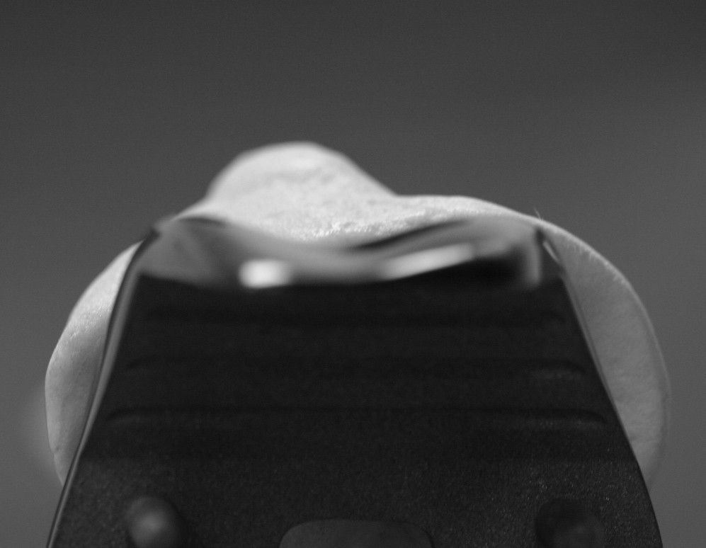

Figure 7a: Ir tib-1-bw.
Position of trochlear groove
when tibial component is centered
at the junction of the medial and
middle 1/3 of the tibial tubercle.

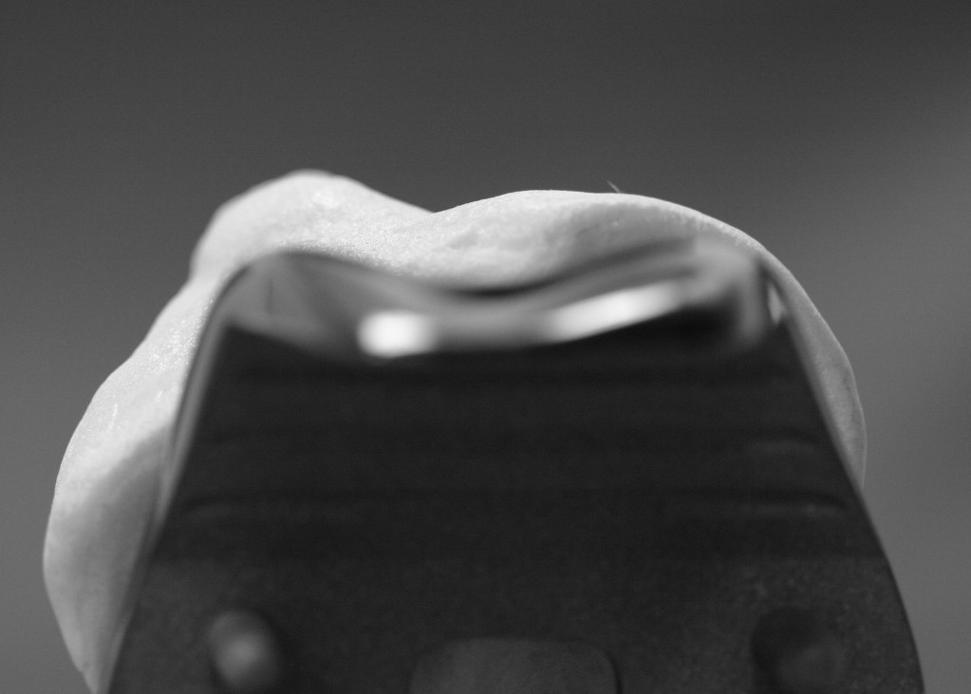

Figure 7b: Ir tib-2-bw.
Tibial component is now
internally rotated.
Tibial tubercle is significantly
lateralized. This markedly
increases Q angle.
Lateral subluxation forces
will pull the patella over the
lateral femoral flange.
The techniques for setting tibial component rotation vary. During surgery, the landmark for the rotational position of the tibial component is the tibial tubercle. The foot and ankle cannot be used as a landmark, as rotational and angular deformities below the knee commonly exist. One common technique is to adjust tibial component rotation with the knee at 90º to optimize geometric mating of the tibial component to the femoral component. This technique prioritizes femoral-tibial component mating. This is accomplished with a tibial trial without a metaphyseal keel or pegs. The tibial trial is rotated to optimize articular mating with the posterior femoral condyles. If this technique is used, the tibial component center should never be internally rotated beyond the medial border of the tibial tubercle. This would increase the Q angle too much. The other common technique is to center tibial component rotation at the junction of the medial and middle 1/3 of the tibial tubercle. This technique prioritizes optimal Q angle. The optimal rotation depends on individual patient anatomy. In all cases, patellar tracking is best when the tibial component is centered in between the medial border and center of the tibial tubercle. Tibial component coverage on the cut tibia is the other competing factor affecting tibial component rotation. In general, the two competing factors can be accommodated with tibial component rotation set over the junction of the medial and middle 1/3 of the tibial tubercle.

Femoral Component Coronal Position

Femoral prosthetic components vary widely in design. In the coronal plane, the height to width ratio determines medial to lateral coverage. Some femoral components look very wide, whereas other components are relatively narrow. A relatively narrow femoral component can be utilized to an advantage in optimizing patellar tracking. Specifically, a narrow femoral component can be laterally displaced several millimeters, and can significantly reduce the Q angle. For optimal patellar tracking, a lateralized femoral component is preferred. A centered femoral component is more than acceptable. However, a medialized femoral component must be avoided, as this increases Q angle.

Tibial Component Coronal Position

The goal with tibial component positioning is to maximize component coverage to prevent settling. Medial cortical rim support is considered a priority for coverage. In addition, the tibial component must be appropriately rotated. However, the surgeon should prevent excess medial placement of the tibial component. A tibial component that is medially placed, in effect, places the tibial tubercle in a relatively more lateral position. This has the detrimental effect of increasing the Q angle. In addition, medial component overhang can impinge upon the medial collateral ligament causing medial knee pain and mechanical abrasion of the ligament. Insufficient exposure, especially in a short obese patient, can force a tibial component more medially than one might expect. Overestimation of medial placement of the tibia is not uncommon in this clinical setting (fig 8).
Photographs demonstrating medialization of tibial component.
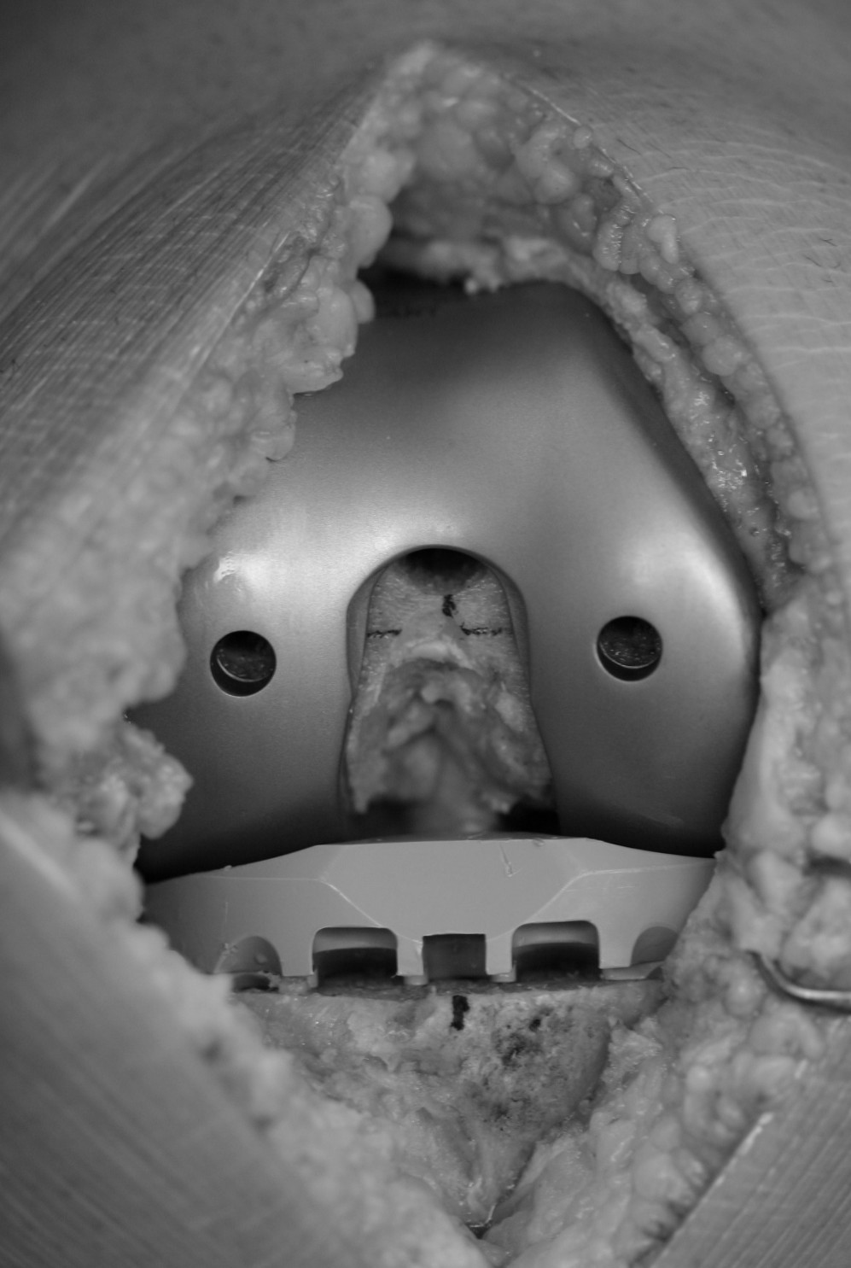

Figure 8a: Overhang-1-bw.
Shows what appears to be
appropriate tibial component
positioning in this obese patient

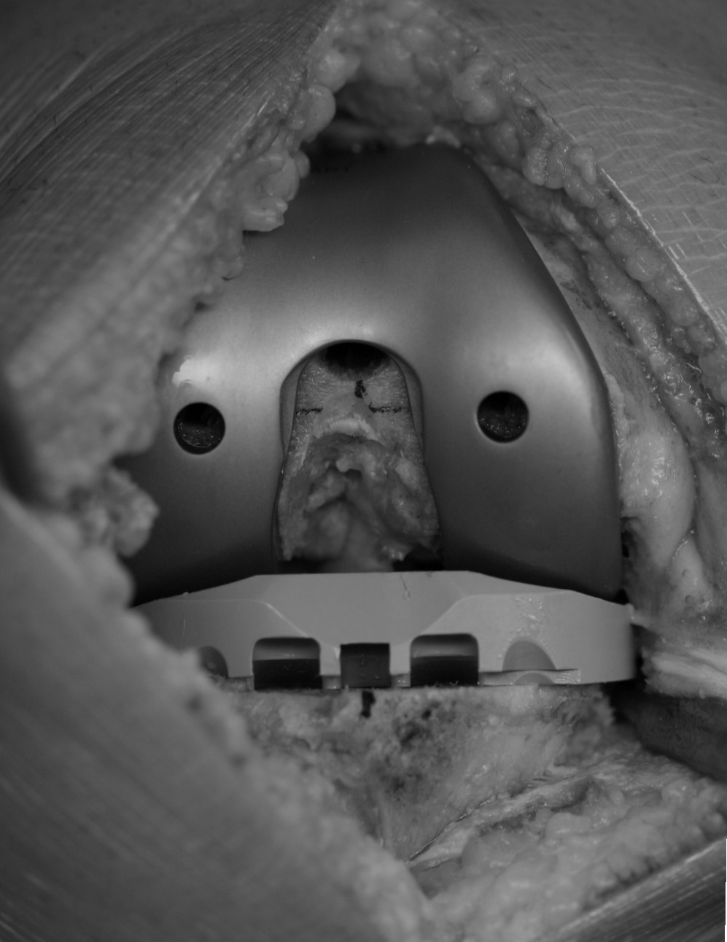

Figure 8b: Overhang-2-bw.
Better exposure reveals medial overhang.
This medial placement of the tibial
component will increase Q angle.

Patellar Component Positioning

The vast majority of patellar components utilized in primary TKA are some variant of a circular dome. However, the native patella is not circular. Most patellae are wider than they are long (fig 9).

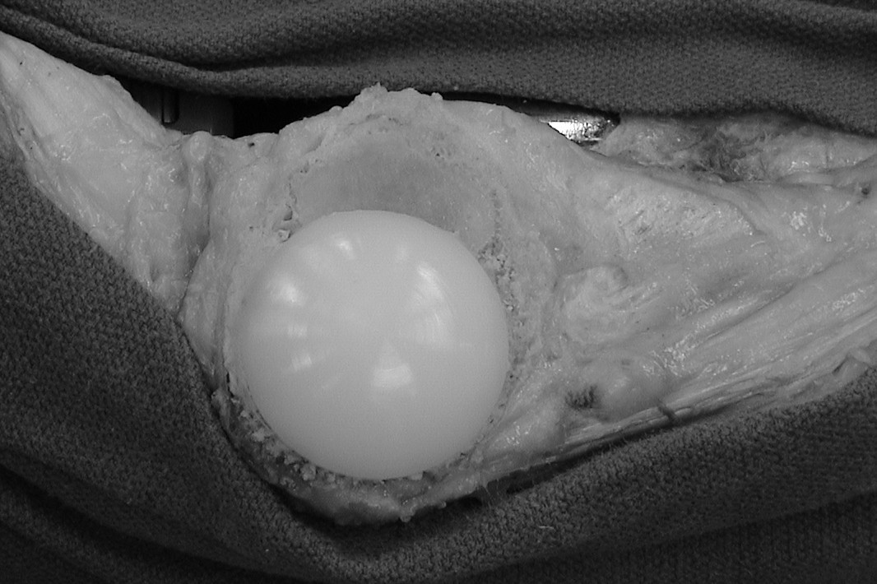
Figure 9: Elliptical patella.
Photograph of resurfaced patella
showing residual unresurfaced bone on lateral aspect of patella.
Not untypically, the native patella tends to be elliptical in shape. When resurfaced with a circular patellar component, not all of the bone can be covered. When this situation occurs, the patellar component should be centered or medialized.

In most applications of circular patella placement, some portion of the patellar bone usually remains uncovered. This discrepancy can be utilized to enhance patellar tracking. Specifically, medialization of the patellar component will decrease the Q angle (fig 10).

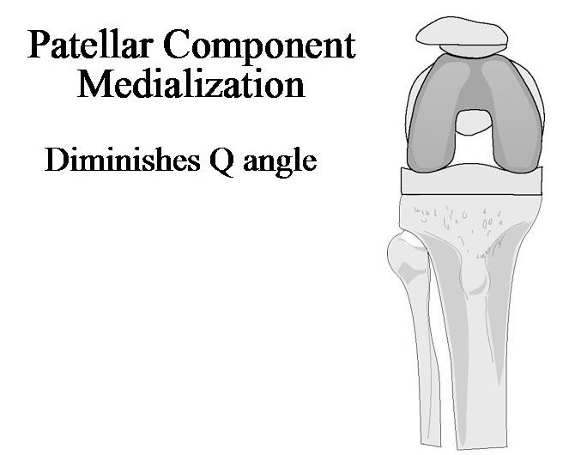

Figure 10: Patellar component medialization.
Diagram showing medialized patellar
component. Native patella is in a
lateral position, thus reducing Q angle.

By placing the patellar component in a medialized position, the remaining patellar bone is in effect in a lateralized position. This has the salutary effect of reducing Q angle. Conversely, lateralization of the femoral component will increase Q angle and should be avoided. A centered patellar component is an acceptable position provided that there is good patellar tracking²⁸.

One caveat is to avoid excessive patellar component medialization when there is a very wide patella. In this scenario, a small circular patellar component placed in the most medialized position can leave a significant amount of lateral patellar bone uncovered. Sometimes the amount of exposed lateral patellar bone can measure as much as 1.5-1.7 cm. This lateral bone can articulate against the lateral trochlear flange and can cause pain. In addition, the unresurfaced lateral patellar bone can ride against the lateral trochlear flange and can alter patellar tilt. Scar tissue can form around the unresurfaced portion of the patella and can manifest with patellar crepitation. When a very wide patella is encountered, a larger diameter patellar component is advocated. Sometimes, when a very wide patella is encountered, some of the lateral patellar bone needs to be resected. This technique is known as a lateral reduction patelloplasty (fig 11).

Photographs demonstrating lateral reduction patelloplasty.
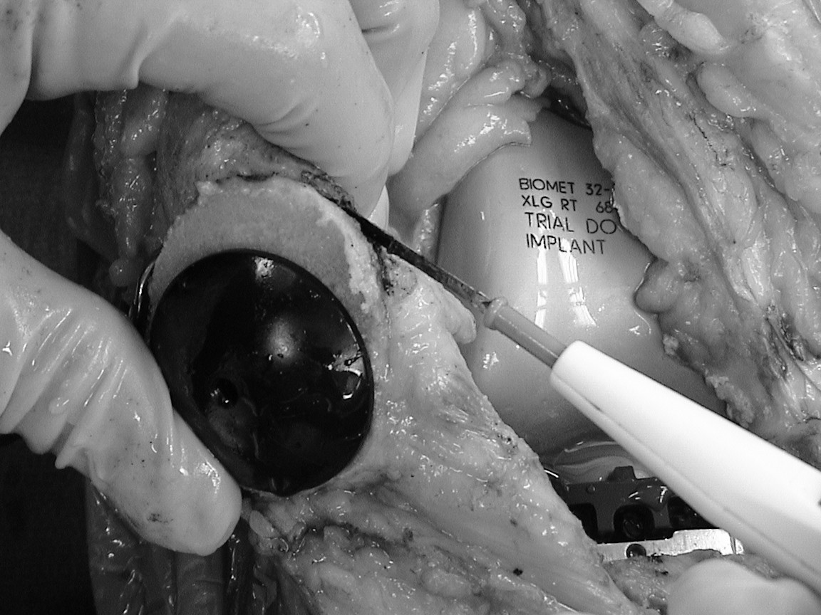

Figure 11a: Reduction patellolasty.
Unresurfaced patellar bone is
dissected with an electrocautery.

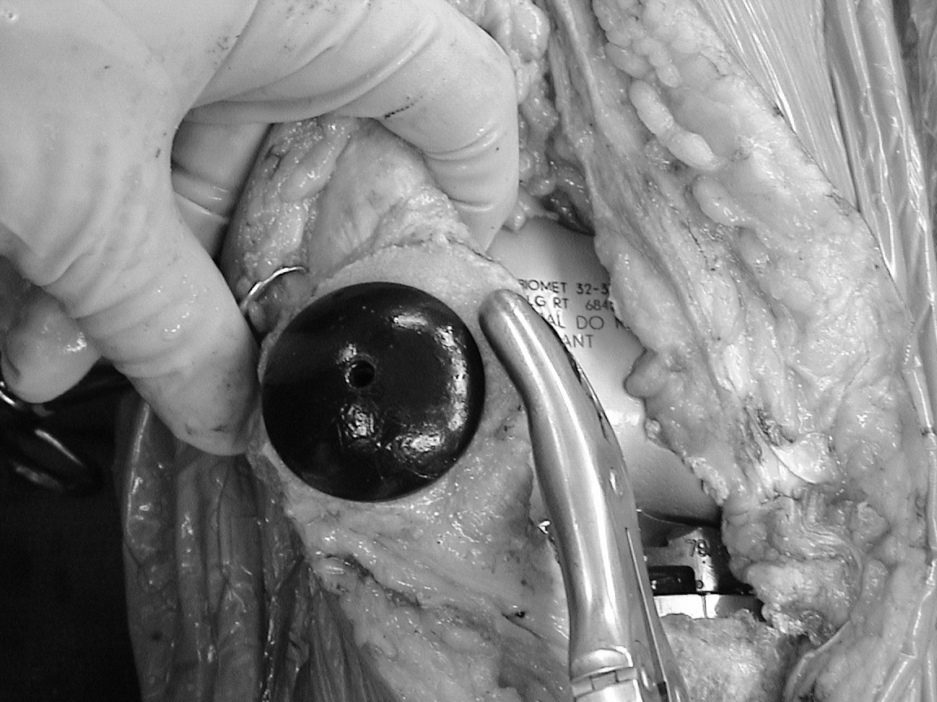

Figure 11b: Reduction patellolasty.
Unresurfaced lateral patellar
bone is removed.

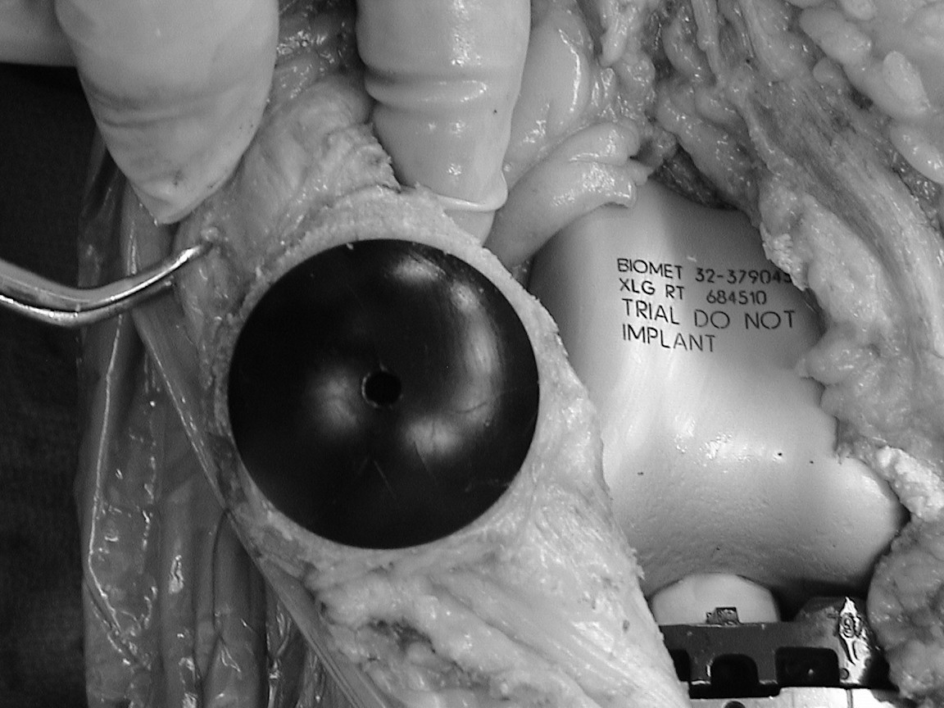

Figure 11c: Reduction patelloplasty.
With bone resection, lateral
retinacular tissues are relieved.

The unresurfaced bone is resected to avoid boney contact of the unresurfaced patellar bone with the femoral component.

The technique of patellar osteotomy must be emphasized. The surgeon must avoid an oblique osteotomy. A resurfaced patella with an oblique bone cut will abnormally tilt the patella and increase shear stresses to the implant. The best way to cut the patella is to follow the anterior cortical surface, which is generally flat. Many patellar cutting jigs have been devised to help prevent oblique cuts, but they are usually cumbersome and are not often used. Assessing the cut patella between the thumb and forefinger (haptic assessment) is a convenient way to recongnize patellar boney obliquity. Haptic assessment has been proven as an acceptable technique to evaluate patellar bone asymmetry ²⁹.

Patellar Height

In the transverse plane, the extensor tendons and capsular structures of the anterior knee envelope the anterior one third of the patella. The patella, which serves as an extensor fulcrum, also lifts the capsule away from the femur-creating capsular tension. Therefore, the height of the patella from the anterior femoral condylar rotational axis is what controls capsular tension. In primary TKA, the technical goal is to restore this height and maintain balanced medial and lateral capsular tension. An increased patellar height must be avoided. An “overstuffed” patellar height increases medial and lateral capsular tension. Because of the Q angle, the increased capsular tension translates into an increased lateral subluxation force upon the patella³⁰.

In primary TKA, the patellar height is controlled by four factors: 1) thickness of patellar bone after cutting 2) thickness of the patellar component 3) thickness of the femoral component and 4) thickness of the remaining femoral trochlear bone (fig 12).
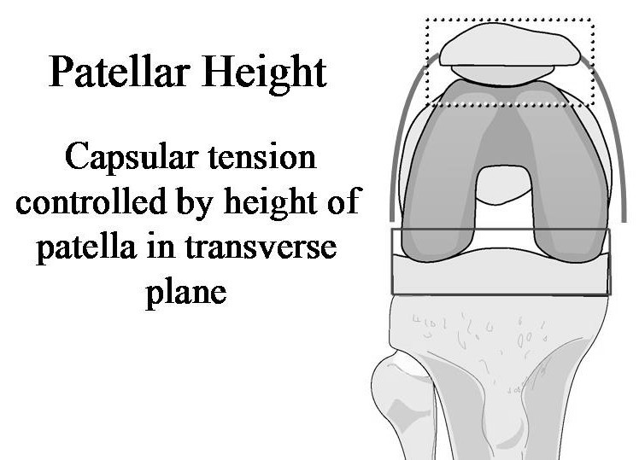

Figure 12: Patellar Height.
Diagram depicting factors
in transverse plane that
control patellar height.
These include thickness
of the patellar bone, thickness
of the prosthetic patella,
thickness of prosthetic
femur, and thickness of
remaining trochlear bone.

With patellar resurfacing, the total thickness of the patella (patellar bone + patellar component) should equal or should be slightly less than the thickness of the native patella ³¹. Patella thickness should be routinely measured with a caliper. This will visually bring to attention the importance of maintaining patellar height. The patella should be cut no thinner than 13mm. Cutting thinner than this risks fracture and avascular necrosis ^{32,33,34}. In small patellae, maintaining normal thickness can be problematic. Patella components have a minimal thickness of polyethylene. A small but thick patellar component may increase patellar thickness. However, the more recent third generation total knee systems do take this problem into account. Some systems now have thinner patellar components available for these special conditions.

On the femoral side, the thickness of the femoral component is a fixed value, but the thickness of the trochlear bone cuts can be adjusted. Underresection of trochlear bone is a common technical error. Prosthetic femoral flanges vary in thickness depending on design, measuring between 5-9mm in thickness. The amount of bone resected should equal or be slightly more than the thickness of the metal flange. With a posterior condylar referencing system, oversizing the femoral component will resect little trochlear bone, and will increase patellar height. The anterior trochlea bone cut should ideally be flush with the anterior femoral cortex. In the situation of being in between sizes, the smaller size should be selected. This may cut the trochlear bone slightly below the anterior femoral cortex, which can be trimmed with a saw into a “cortical blend”. It may cause a small notch. However, this is generally more palatable than overstuffing patellar height and having problems with patellar tracking. Notching the femoral cortex more than 1-2 mm should be avoided. Measuring the resected trochlear bone with a caliper is a good habit to employ.
Patellar Resurfacing

No other topic creates more controversy and worldwide polarization in the technique of primary TKA than that of patellar resurfacing. The main issue is the problem of residual anterior knee pain after primary TKA^{35,36}. There are three camps of philosophy: those who never resurface, those who always resurface, and those who selectively resurface. Interestingly, there are very few surgeons who selectively resurface, and this is likely due to mindset entrenchment during training. The studies on this issue vary widely, and this reflects the strong diametric views on this topic. Patients with inflammatory arthritis, crystalline deposition disease, significant patellofemoral dysplasia, or severe patellar arthritis have significantly better function with patellar resurfacing³⁷. In patients with osteoarthritis, the incidence of residual anterior knee pain in well controlled prospective randomized studies in early follow-up is similar whether or not the patellar is resurfaced ^{38,39}. However, longer follow-up has shown a gradual progressive increase in pain in patients with unresurfaced patellae. In the United States, the majority of surgeons routinely resurface the patella.

Among the surgeons who do not routinely resurface the patella and do have substantial clinical experience with this practice, there are common technical themes that standout. First, the design of the femoral trochlear groove should be of an anatomic design. Instead of a trochlear groove that has a radius similar to the patellar dome geometry, an anatomic trochlear groove is “V” shaped and accommodates its surfaces to match the native patellar facets. This maximizes contact areas and reduces contact stress loads to the unresurfaced patella. In addition, a native patella tracking in a non-anatomic curved trochlea will tilt laterally, as there is no place for the central patellar ridge to articulate. The primary articulation will be upon the lateral patellar facet. A “V” shaped anatomic trochlear groove will allow the patella to stay upright. Second, the anatomic femoral component requires an additional bone cut in the trochlea to recreate the anatomic trochlear sulcus. This “5^{th”} cut deepens the patellar grove, and ensures that patellar height is not overstuffed. Third, circumferential deinnervation of the patella is emphasized with this technique. Specifically, deinnervation is carried out with an electrocautery, and should extend below the tendon insertion into the patella by 1.0mm. This one technical point alone may explain some of the discrepancy in studies examining residual anterior knee pain with unresurfaced patellae. Fourth, debridement of patellar osteophytes is encouraged. There should be no other bone articulating with the femoral component other than the patellar facets. Lastly, proper anterior placement of the femoral component is strictly enforced. The anterior trochlear bone cut is either made flush with the anterior femoral cortex, or slightly below with a “cortical blend”.
Summary

The management of the patellofemoral joint in primary TKA in essence is to understand all implications related to the Q angle at the knee joint. Alignment and rotation of prosthetic implants, as well as soft tissue tensioning of knee soft tissue structures all effect lateral subluxation forces at the patellofemoral joint. Since the most frequent problems in primary TKA involve the patellofemoral joint, surgical technique should prioritize appropriate patellofemoral alignment and normalize patellofemoral capsular tension. The following rules and guidelines should be compulsory surgical technique:

- Bone cuts should achieve neutral mechanical alignment. Avoid excess valgus above 7º.
- Internal rotation of femoral and tibial components must be avoided.
- Lateralize femoral component when possible. Avoid femoral component medialization.
- Avoid tibial component medialization (i.e. medial overhang).
- Medialize patellar component when possible. Avoid patellar component lateralization.
- Make patellar bone cuts parallel to anterior surface of patella. Do not make an oblique patellar cut.
- Do not “overstuff ” patellofemoral height.
- If the patella is not resurfaced, employ an anatomic tochlear design with a deepened trochlear groove.
BIBLIOGRAPHY

1. Parker D, Dunbar M, Rorabeck C: Extensor mechanism failure associated with total
knee arthroplasty: prevention and management. J Am Acad Orthop Surg.
2003 Jul-Aug; 11(4):238-47.

2. Ritter M, Herbst S, Keating E, Faris P, Meding J: Patellofemoral complications
Following total knee arthroplasty. Effect of a lateral release and sacrifice of the
Superior lateral geniculate artery. J Arthroplasty. 1996 Jun; 11(4):368-72.

3. Theiss S, Kitziger K, Lotke P, Lotke P: Component design affecting patellofemoral
Complications after total knee arthroplasty. Clin Orthop. 1996 May; (326) 183-7.
4. Leblanc J: Patellar complications in total knee arthroplasty. A literature review.
Orthop Rev. 1989 Mar;18(3):296-304.

5. Brick G, Scott R; The patellofemoral component of total knee arthroplasty. Clin
Orthop. 1988 June; (231): 163-78.

6. Mont M, Yoon T, Krackow K, Hungerford D: Eliminating patellofemoral
complications in total knee arthroplasty: clinical and radiographic results of 121
consecutive cases using the Duracon system. J Arthroplasty. 1999 Jun; 14(4):446-
55.
7. Hungerford D, Barry M: Biomechanics of the patellofemoral joint. Clin Orthop.
1979 Oct;(144):9-15.

8. Buff H, Jones L, Hungerford D: Experimental determination of forces transmitted
Through the patello-femoral joint. J Biomech. 1988;21(1):17-23.

9. Ahmed A: Biomechanics of the Patellofemoral Articulation Relevant to Total Knee
Replacement, in Fu F, Harner C, Vince K (Ed): Knee Surgery, Volume 2, Baltimore,
MD, Williams and Wilkins, 1994, pp 1429-1450.

10. Kelly M: Patellofemoral complications following total knee arthroplasty.
Instr Course Lect. 2001; 50: 403-7.

11. McPherson E: Vince K: The Patella in total knee arthroplasty. Orthop Clin North
Am. 1992 Oct;23(4):675-86.

12. Malo M, Vince V: The unstable patella after total knee arthroplasty: etiology,
prevention, and management. J Am Acad Orthop Surg. 2003 Sept-Oct; 11 (5):
364-71.

13. Takahashi M, Miyomoto S, Nagano A: Arthroscopic treatment of soft-tissue
impingement under the patella after total knee arthroplasty. Arthroscopy. 2002
Apr; 18(4):E20.

14. Pollock D, Ammeen D, Engh G: Synovial entrapment: a complication of posterior
stabilized total knee arthroplasty. J Bone Joint Surg Am. 2002
Dec; 84-A(12):2174- 8.

15. Larson C, Lachiewicz P: Patellofemoral complications with the Insall-Burstein II
posterior-stabilized total knee arthroplasty. J Arthroplasty. 1999 Apr; 14(3):288-92.

16. Anderson M, Becker D, Kieckbusch T: Patellofemoral complications after
Posterior-stabilized total knee arthroplasty: a comparison of 2 different implant
Designs. J Arthroplasty. 2002 Jun; 17(4):422-6.

17. Jobe C, Wright M: Anatomy of the Knee, in Fu F, Harner C, Vince K (Ed):
Knee Surgery, Volume 1, Baltimore, MD, Williams and Wilkins, 1994, pp 1-53.

18. Moreland J, Bassett L, Hanker G: Radiographic analysis of the axis alignment of the
lower extremity. J. Bone Joint Surg., 1987, 69-A, 745-749.

19. Berger R, Crossett L, Jacobs J, Rubash H: Malrotation causing patellofemoral
complications after total knee arthroplasty. Clin Orthop. 1998 Nov; (356): 144-53.

20. Rhoads D, Noble P, Reuben J. Mahoney O, Tullos H: The effect of femoral component
position on patellar tracking after total knee arthroplasty. Clin. Orthop., 1990, 260, 43.

21. Nagamine R, Whiteside L, Otani T, White S, McCarthy D: Effect of medial
Displacement of the tibial tubercle on patellar position after rotational malposition of
The femoral component in total knee arthroplasty. J Arthroplasty. 1996 Jan;
11(1):104-10.

22. Arima J, Whiteside L, McCarthy D, White S: Femoral rotational alignment,
based on the anteroposterior axis, in total knee arthroplasty in a valgus knee.
A technical note. J Bone Joint Surg Am. 1995 Sep;77(9):1331-4.

23. Cooke T, Bryant T, Scudamore R: Mechanical Factors in Alignment and
Arthritic Disorders of the Knee, in Fu F, Harner C, Vince K (Ed): Knee Surgery,
Volume 2, Baltimore, MD, Williams and Wilkins, 1994, pp 1061-1078.30.

24. McPherson E: Adult Reconstruction, in Miller, M, Brinker M (Eds): Review of
Orthopaedics. Ed 4. Philadelphia, PA, W.B. Saunders Company, 2004.

25. Whiteside L, Arima J: The anteroposterior axis for femoral rotational alignment
in valgus total knee arthroplasty. Clin Orthop. 1995 Dec;(321):168-72.

26. Poilvache P, Insall J, Scuderi G, Font-Rodriguez D: Rotational landmarks and sizing
of the distal femur in total knee arthroplasty. Clin Orthop. 1996 Oct;(331):35-46.

27. Mantas J, Bolebaum R, Skedros J, Hoffmann A: Implications of reference axes used
for rotational alignment of the femoral component in primary and revision knee
arthroplasty. J. Arthroplasty, 1992, 7, 531.

28. Yoshii I, Whiteside L, Anouchi Y: The effect of patellar button placement and
femoral component design on patellar tracking in total knee arthroplasty. Clin.
Orthop., 1992, 275, 211-219.

29. DeOrio J, Peden J: Accuracy of haptic assessment of patellar symmetry in total knee
arthroplasty. J Arthroplasty. 2004 Aug; 19(5):629-34.

30. Oishi C, Kaufman K, Irby S, Colwell C: Effects of patellar thickness on
compression and shear forces in total knee arthroplasty. Clin Orthop.
1996 Oct;(331):283-90.

31. Hsu H, Luo Z, Rand J, An K: Influence of patellar thickness on patellar tracking
and patellofemoral contact characteristics after total knee arthroplasty.
J Arthroplasty. 1996 Jan;11(1):69-80.

32. Lie D, Gloria N, Amis A, Lee B, Yeo S, Chou S: Patellar resection during
Total knee arthroplasty: effect on bone strain and fracture risk. Knee Surg
Sports Traumatol Arthrosc. 2004 May 4; [Epub ahead of print].

33. Koh J, Yeo S, Lee B, Lo N, Seow K, Tan S: Influence of patellar thickness on
results of total knee arthroplasty: does a residual bony patellar thickness of <or=12
mm leads to poorer clinical outcome and increased complication rates?. J.
Arthroplasty. 2002 Jan; 17(1):56-61.
34. Reuben M, McDonald C, Woodard P, Hennington L: Effect of patella thickness on
patella strain following total knee arthroplasty. J. Arthroplasty, 1991, 6, 251-258.

35. Holt G, Dennis D: The role of patellar resurfacing in total knee arthroplasty. Clin
Orthop. 2003 Nov; (416): 76-83.

36. Burnett R, Bourne R: Indications for patellar resurfacing in total knee arthroplasty.
Instr Course Lect. 2004;53:167-86.

37. Hanssen A: Orthopaedic crossfire—All Patellae should be resurfaced during
Primary total knee arthroplasty: in the affirmative. J Arthroplasty. 2003 Apr; 18(3
Suppl 1):31-4.

38. Waters T, Bentley G: Patellar resurfacing in total knee arthroplasty. A prospective,
randomized study. J Bone Joint Surg Am. 2003 Feb; 85-A(2):212-7.

39. Mayman D, Bourne R, Rorabeck C, Vaz M, Kramer J: Resurfacing versus not
Resurfacing the patella in total knee arthroplasty: 8-to 10-year results.

